**Customer relationship management**

*Submitted in 1st review for the award of the degree of*

**Master of science**

*in*

**software engineering**

*By*

**Chandrasekar.H (08MSE049)**

*Under the Guidance of*

**Prof. Bhavani**

**Asst.Professor, SITE,**

**VIT University.**



**SCHOOL OF INFORMATION TECHNOLOGY & ENGINEERING**

**Feb 2013**

Customer Relationship Management:

Abstract:

**Customer relationship management** (**CRM**) is a model for managing a company’s interactions with current and future customers. It involves using technology to organize, automate, and synchronize sales, marketing, customer service, and technical support. The product simplifies a company's interaction with their clients and classifies the interaction conducted based on services.

Introduction:

To grow revenue you need a Customer Relationship Management application that helps you track sales activity—every lead, opportunity, and customer, especially when you’re on the go. In today’s mobile business environment, there’s no reason for a big up-front software investment that's expensive to install and maintain. Customer relationship management, also known as CRM, is the study and practice of implementing ways in order to streamline the customer relationship. Customer relationship management can help a company to not only flag potential new clients, but it can also help to keep and maintains the ones that they currently have as clients. The top two reasons that a client leaves a company is either displeasure at their treatment or lack of loyalty. Many customers have an out of sight out of mind mentality, and that means that if you do not keep up with the client and follow-up properly you will most likely lose them.

Existing System:

**Zoho Analytics:**

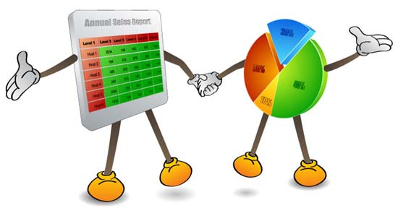

**CRM Dashboards**

* Flash-based, interactive CRM dashboards with an aesthetically pleasing layout and fast loading capability
* Fully customizable Sales dashboards with different types of Bar, Funnel, Pie, and Line charts
* Drill down Sales charts for further data analysis
* Display charts in customized home page

**WebAsyst:**

WebAsyst is a suite of web applications for online collaboration and ecommerce. WebAsyst allows sharing data and files, organizing contacts with your colleagues and friends, opening an online store.

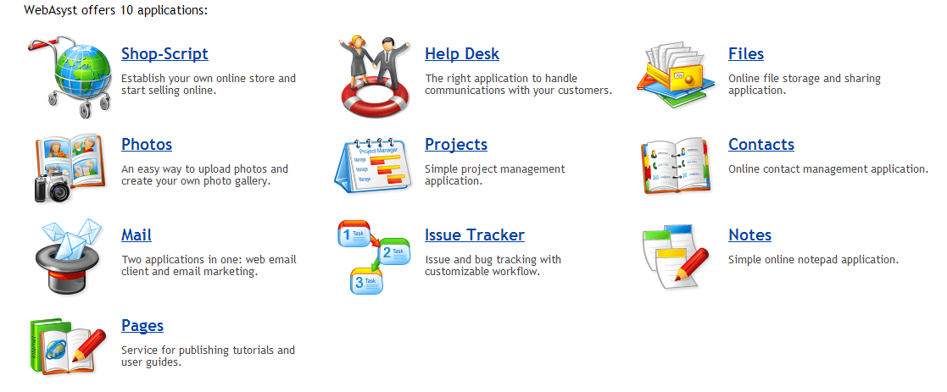

Every WebAsyst application works well without all others installed. For example, you may use only Files for sharing files, or only Shop-Script to create an online store, or only Photos for publishing photos online, without other applications that you don't need.

Literature Survey:

|  |  |  |  |  |  |  |  |
| --- | --- | --- | --- | --- | --- | --- | --- |
| Companies/Features | E-mail Integration | Web Hosted Solution | Dialing Capabilities | Mobile Access | Reporting options | Social Networking | Real Time Alerts |
| Sales Force | Yes | Yes | Yes | Yes | Yes | Yes | Yes |
| Relenta | No | Yes | No | Yes | Yes | No | No |
| WebAsyst | Yes | Yes | No | No | Yes | Yes | Yes |
| AlMcrm | Yes | Yes | Yes | Yes | Yes | Yes | Yes |
| Team Wox | Yes | Yes | Yes | Yes | Yes | No | Yes |
| Chaos Intellect | Yes | Yes | Yes | Yes | Yes | No | Yes |
| On Contact | Yes | Yes | Yes | Yes | Yes | Yes | Yes |

Architecture Diagram:

Calendar, Alerts

Messaging

Customer

Customer Relationship Management

Re

Customary Reports

Invoice Billing

View

Reports

Charts

Smart Phone Integration

Mail

Dynamic Status Update

Analytics

Video Conferencing

Invoice

Proposed System:

1. **In-Depth Analytics on multiple services:**

**Analytics: Importance**

Analytics often favors data visualization to communicate insight. Firms may commonly apply analytics to business data, to describe, predict, and improve business performance. Analytics on usage, cost, and fault rate gives insight for the customer regarding service used. For example Air show buzz is a leading hub for air show enthusiasts. Their page views, content views, and data analytics, helped in tracking user’s interest – lead to a new dimension for viewing their system.

**Analytics: Model**

Context: Messaging

Customer has to keep track of the number of messages sent, received, blocked, invalid phone numbers, etc. Reports and graphs are dynamically generated based on time. Messages are classified based on sections such as advertisements, notifications. The messages sent versus denied, user’s response for every message statistics are recorded. This information is presented in visually appeasing format.

Context: Mail

Bulk email software is software that is used to send email in large quantities. It is generally used for legitimate mailings, such as for email list subscribers. Every mail, sent via third party service has to be kept in record for business purposes. Mails are sent to advertise customer’s product, notify an existing user. Third party vendor handles the mail service for the customer delivers this context sensitive information.

**Role: Third Party Vendor**

This software is prepared by third party vendor, who creates analytics for user as an auxiliary. These analytics are key facts for decision support systems, and to have an insight on customer’s business. CRM is a tool to bridge the problems of the customers with the solutions offered by the companies. This tool simplifies a company's interaction with their clients and classifies the interaction conducted based on services.

1. **Smart Phones Integration:**

Smart Phone Integration is about being "in the office" even when you're out of the office—to be completely available. Many CRMs allow you to connect from your smartphone and pull out useful data on prospects and customers. It's easy to retrieve a customer's order history or your background with a prospect, keeping you armed with vital information. The interface is customized to be viewed on user’s device by retrieving information from the database connected via internet. Customer has access to all the resources, schedule appointments, have video conferencing with responsible person in the same device.

1. **Dynamic Status Update:**

We use dynamic status update to know the current progress and make decisions based on it. The analytics of services offered depends on several variables. Dynamics status update gives current information on the service used, subjected to multiple variables.

1. **Invoice Billing:**

This tool provides an insight on billing procedures for client who use the service of the company for any information exchange. Many factors such as client specific discounts, number of messages, the number of bytes sent and cost per message are considered. Change in client’s information influences on the bill generated.

Customary invoices are easier for client to monitor their usage. History of usage, critical information influencing the bill is provided. Monitoring usage of clients does play a major role in generating user specific invoices.

This product will provide statistics on the revenue generated for a particular time period. It is mandatory for the top-level management to take decisions based on the revenue, which changes from time to time. This product provides time specific transaction details and charts which favors the management team.

Client specific criteria are established, so as to facilitate billing, based on the offers mentioned. This invoice is a single product which facilitates multiple clients, services and transactions.

This product provides client specific customary invoices which deliver information required based on their own options. This product generates an invoice based on a client’s usage.